**Memo: Setting Up a System for Consumer Insights**

**Subject:** Implementation of a Customer Insights System for Top Customer Identification and Spending Pattern Analysis

**1. Introduction**

This memo outlines the implementation of a comprehensive customer insights system designed to identify our most valuable customers and analyze their spending patterns. This system will leverage data processing, storage, and visualization tools to provide actionable insights into customer behavior for informed decision-making.

**2. System Setup Overview**

**2.1. Data Collection and Storage**

**Data Sources:**

* **Customer Data:** Includes customer demographics, transaction history, and engagement metrics.
* **Transaction Data:** Details of purchases, amounts spent, and transaction timestamps.

**Storage Solution:**

* **Database:** We will initially utilize a lightweight, file-based database like SQLite for data storage during development. However, for production environments with larger data volumes, a scalable solution like PostgreSQL or MySQL will be considered.
* **ETL Process:** Data will be processed through an Extract, Transform, Load (ETL) pipeline to convert raw data into structured formats suitable for analysis.

**Tools:**

* **Python** will be used for data processing and ETL tasks. **Pandas** will facilitate data manipulation and cleaning, while the chosen database management system **(SQLite/PostgreSQL/MySQL)** will ensure data storage.

**2.2. Data Processing**

**Steps:**

1. **Load Data:** Importing raw data from CSV files into dataframes using Pandas.
2. **Data Cleaning:** Addressing missing values, correcting data types, and ensuring overall data quality.
3. **Data Transformation:** Aggregating data, calculating relevant spending metrics, and updating the database with new and changed records.

**Tools:**

* **Pandas:** For data manipulation and transformation.
* **SQLite3/SQLAlchemy:** For database interactions.

**2.3. Data Analysis and Visualization**

**Objectives :**This stage aims to:

* Identify top customers based on total spending.
* Analyze spending patterns over time.
* Visualize customer segments and spending distribution.

**Tools:**

* **Python Libraries:** Matplotlib and Seaborn for visualizations.
* **Looker Studio:** For interactive analysis and visualization.

**Visualizations:**

* **Top Customers:** Bar charts showing total spending by customer.
* **Spending Patterns:** Line graphs illustrating spending trends over time.
* **Customer Segments:** Pie charts or histograms depicting customer distribution by spending brackets.

Dashboard Link: *https://lookerstudio.google.com/reporting/e95d2a3a-5f00-431d-8427-bfc513af79d1*

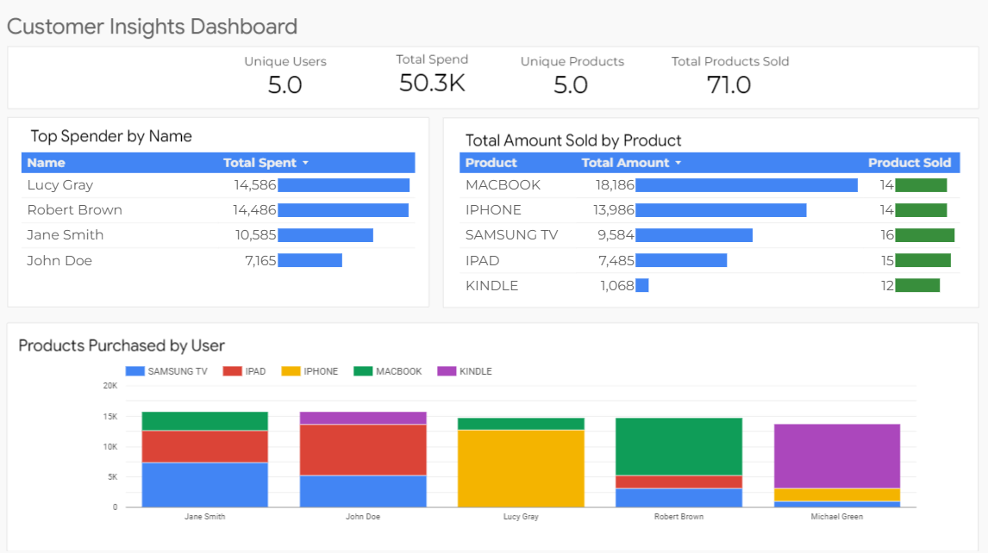

**2.4. Reporting and Insights**

**Objectives:**

* Generate periodic reports summarizing key findings.
* Provide actionable insights for marketing and customer engagement strategies.

**Tools:**

* **Looker Studio:** For creating detailed reports with visualizations.
* **PDF Export:** For sharing reports with stakeholders.

**3. Unit Tests**

To ensure the reliability of the ETL pipeline and data processing functions, unit tests will be implemented. These tests will cover:

1. **Data Loading:** Verify that data is correctly loaded from CSV files.
2. **Data Transformation:** Check that transformations (e.g., handling missing values) are applied correctly.
3. **Database Operations:** Ensure that new transactions are appended correctly and existing users are updated without duplication.
4. **Error Handling:** Validate that exceptions are logged and handled appropriately.

**Tools:**

* **pytest:** For unit testing Python code.
* **unittest:** Standard Python library for writing and running tests.

**4. Conclusion**

This system setup will provide a robust framework for identifying top customers and analyzing spending patterns. By integrating data processing, storage, and visualization tools, we will deliver valuable insights to support strategic decision-making. Regular updates and unit testing will ensure the reliability and accuracy of the system.

Please let me know if you have any questions or require further details.